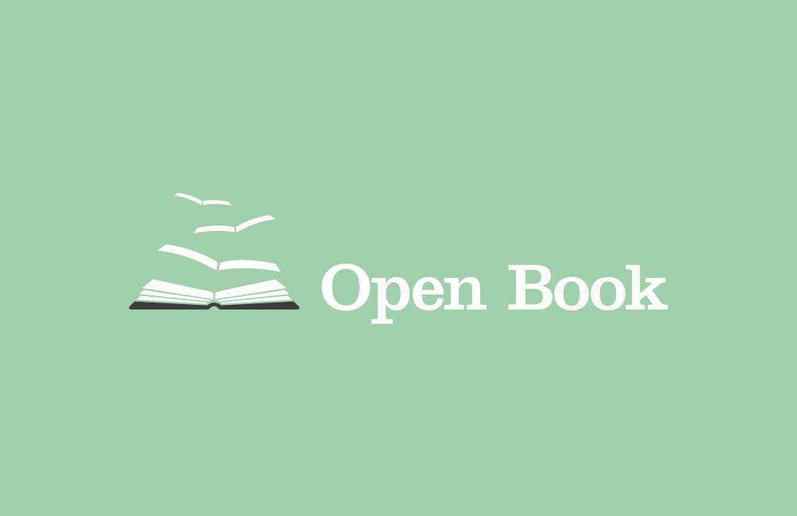
Our aim is to organise and facilitate reading groups for disadvantaged and vulnerable adults and the elderly, and then arrange and fund attendance at a linked event through the Edinburgh International Book Festival.

If you would like to get involved in any of the following ways please leave your details.

NAME __________________________________________________________

EMAIL __________________________________________________________

CONTACT NO.____________________________________________________

Join our email list and keep in touch with our projects
Donate one copy of a book to be used at a reading session
Donate a set of books to be used at a reading session
Join a review panel to read books for suitability
Help/attend the annual visit with a group to the Edinburgh International Book Festival
Attend a session/ training with a view to being a reserve/occasional facilitator
Attend training/ become a group facilitator (1 hour plus travel time commitment per week )

Once completed, you can upload this form at www.openbookreading.com or email it to Marjorie@openbookreading.com

